Q1. Create a class Address for Author with instance variables streetNumber, location, State.
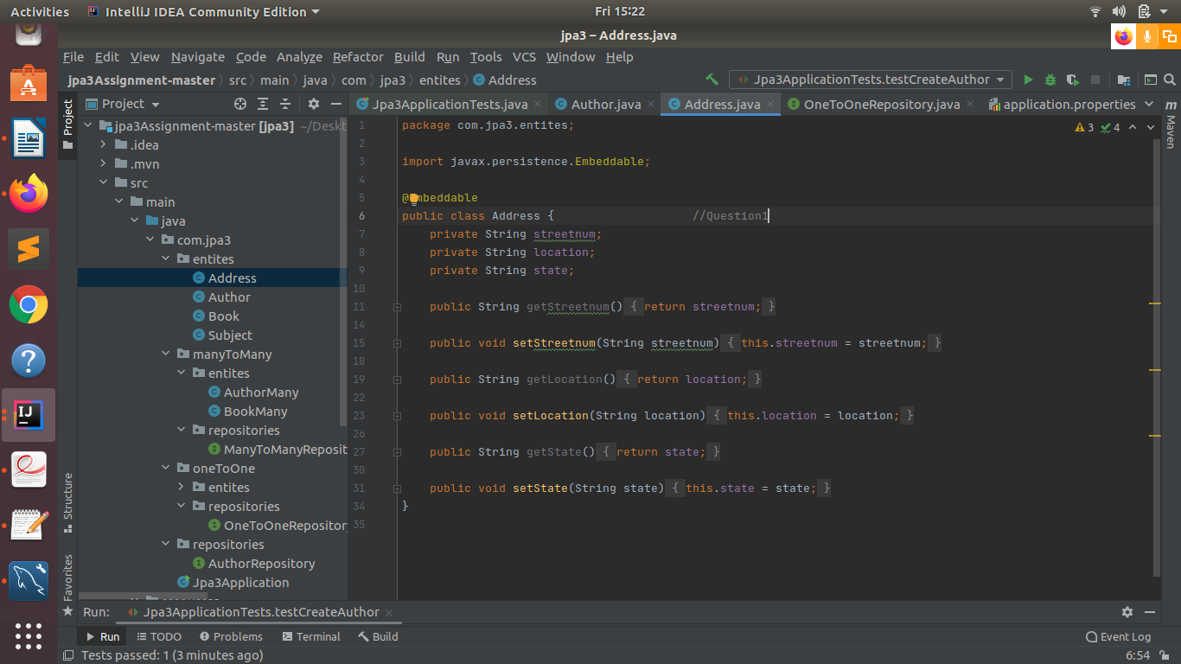

Q2.Create instance variable of Address class inside Author class and save it as embedded object.

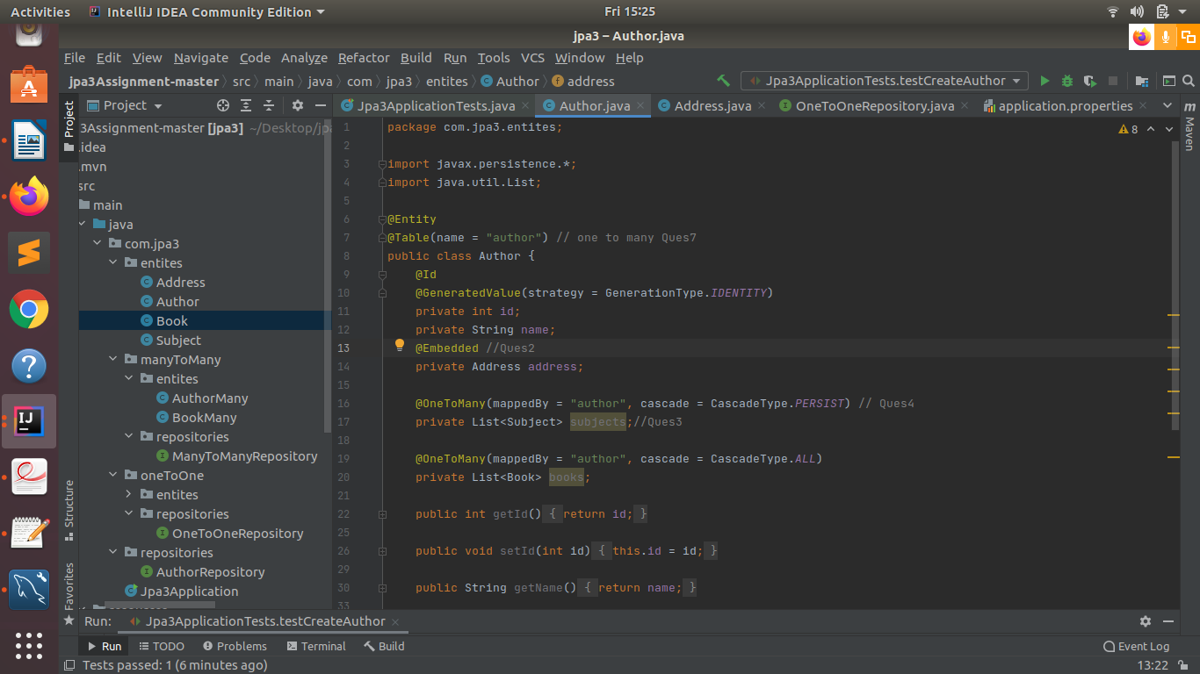

Q3.Introduce a List of subjects for author.
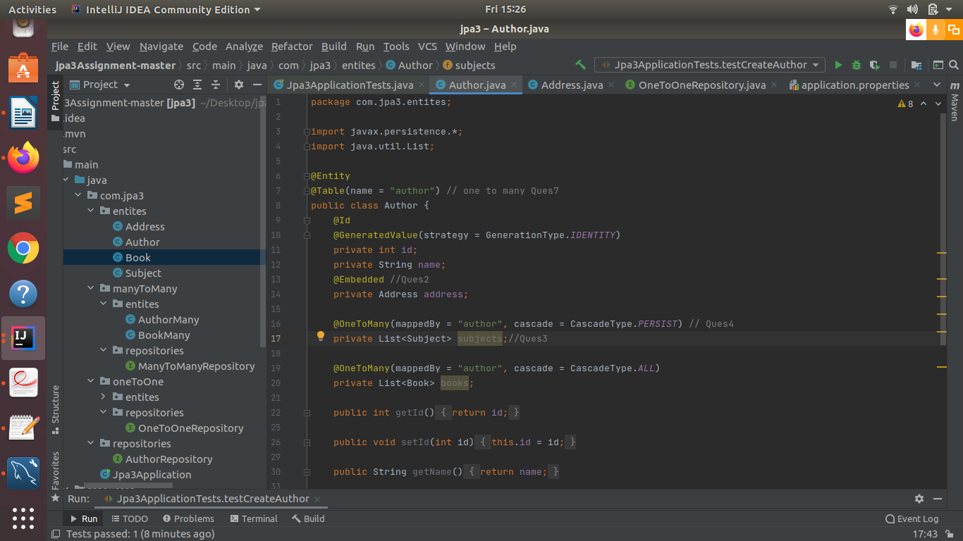

Q4,Persist 3 subjects for each author.
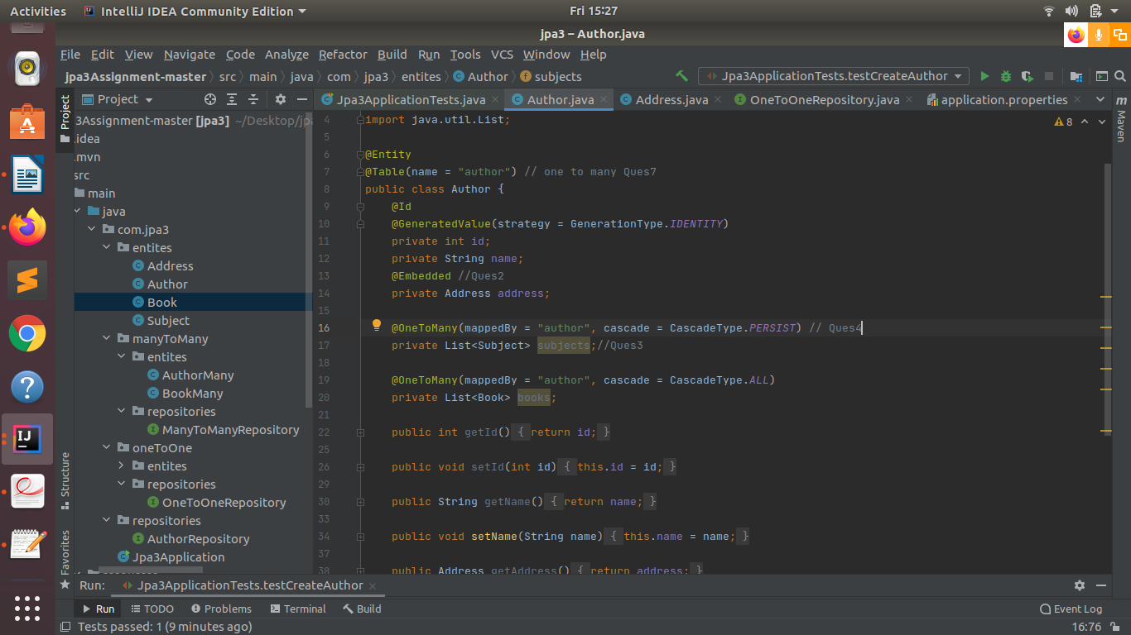

Q5.Create an Entity book with an instance variable bookName.
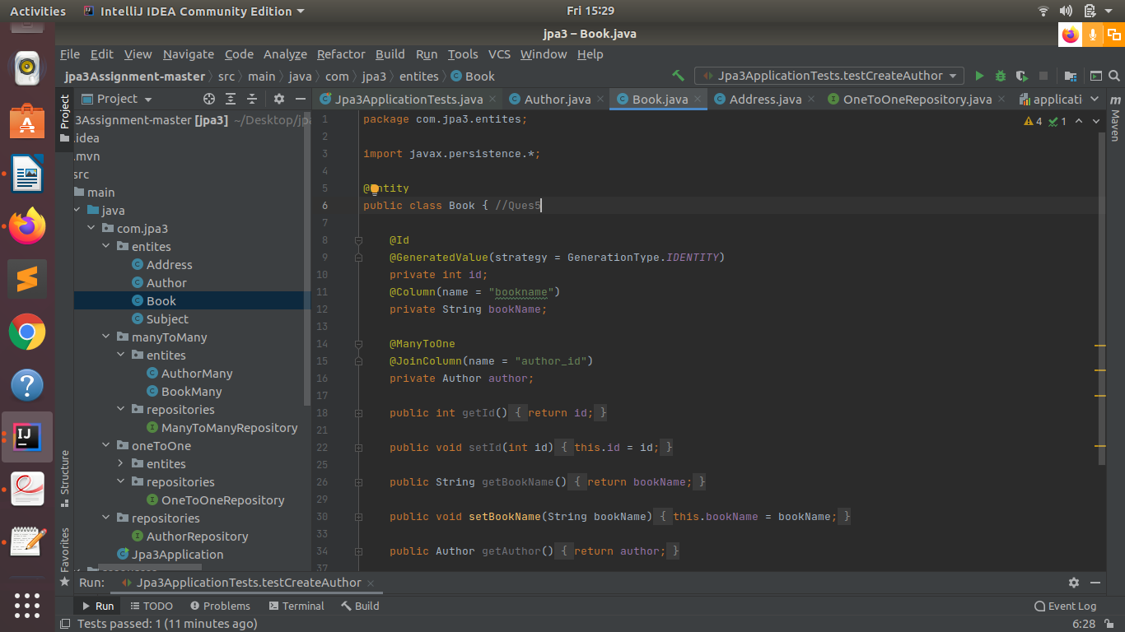

Q6.Implement One to One mapping between Author and Book.
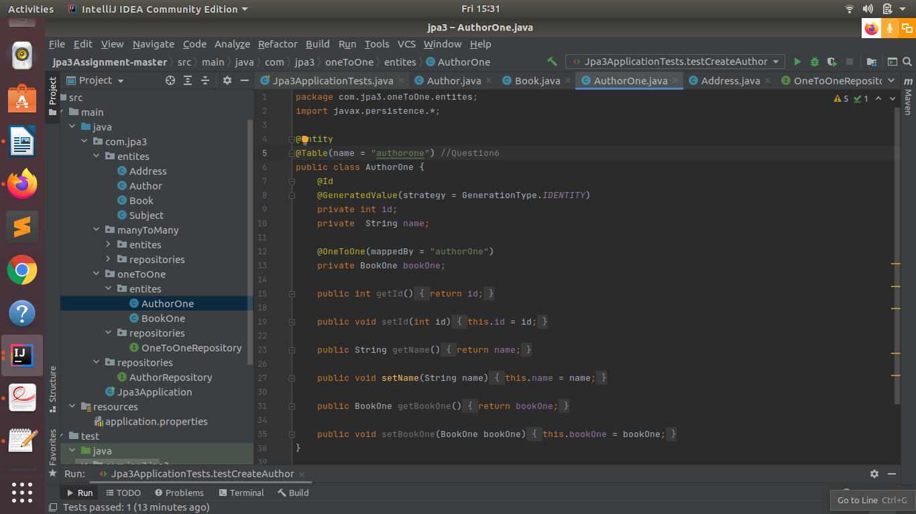

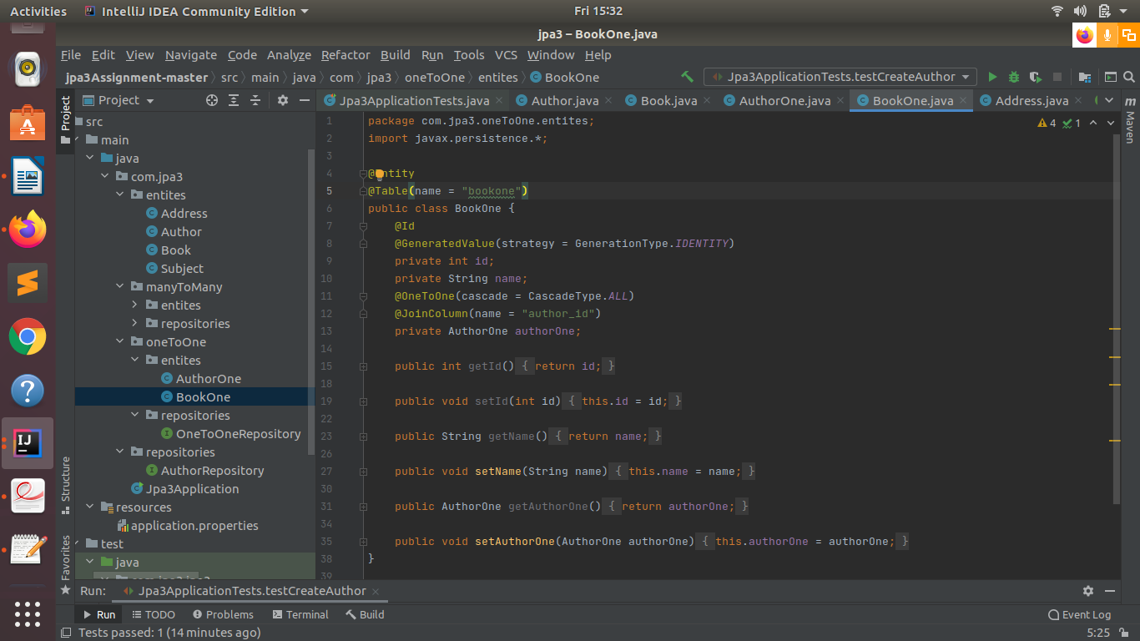
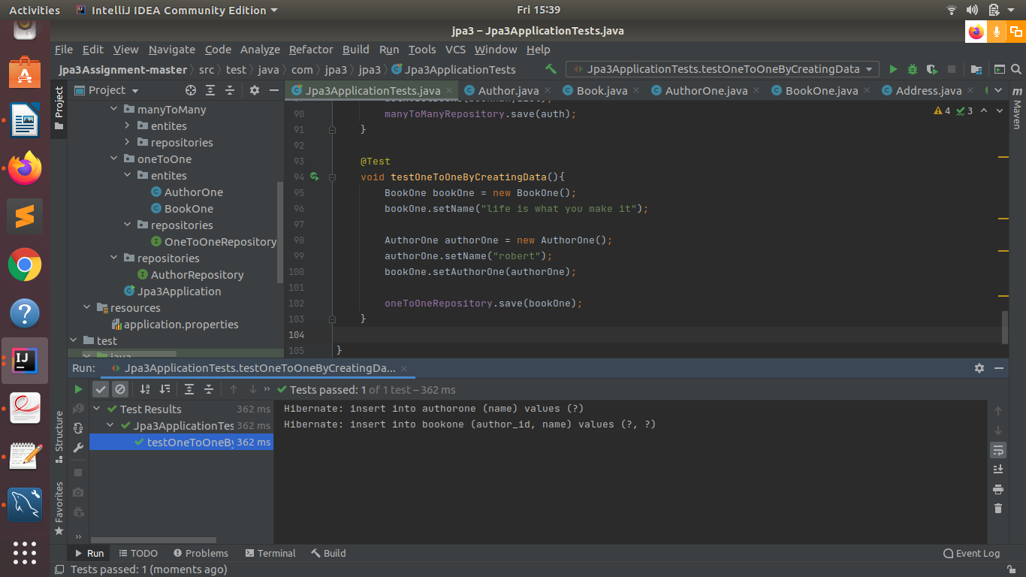

Q7.Implement One to Many Mapping between Author and Book(Unidirectional, BiDirectional and without additional table ) and implement cascade save.
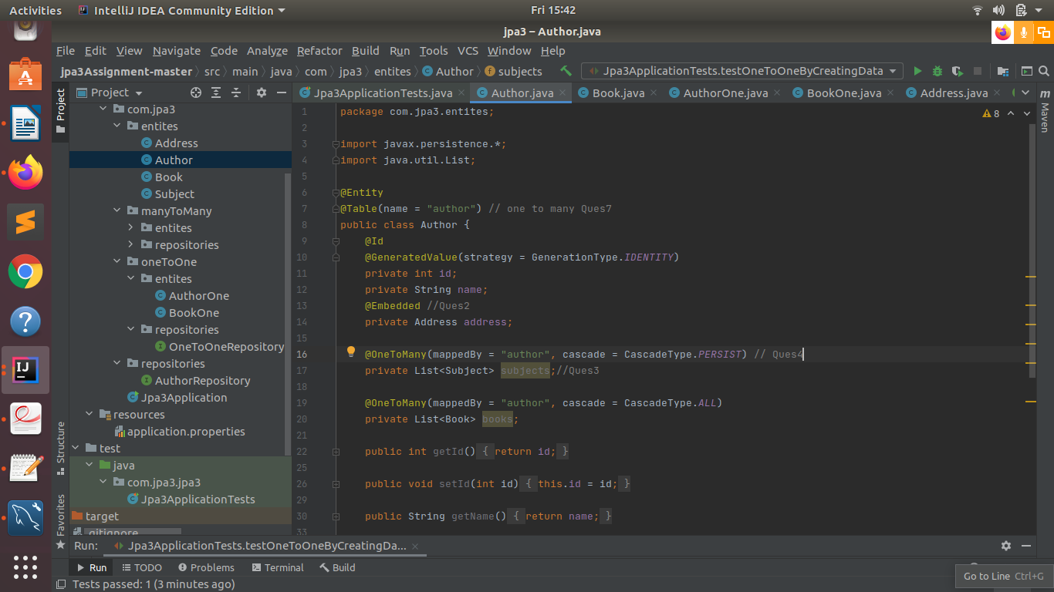
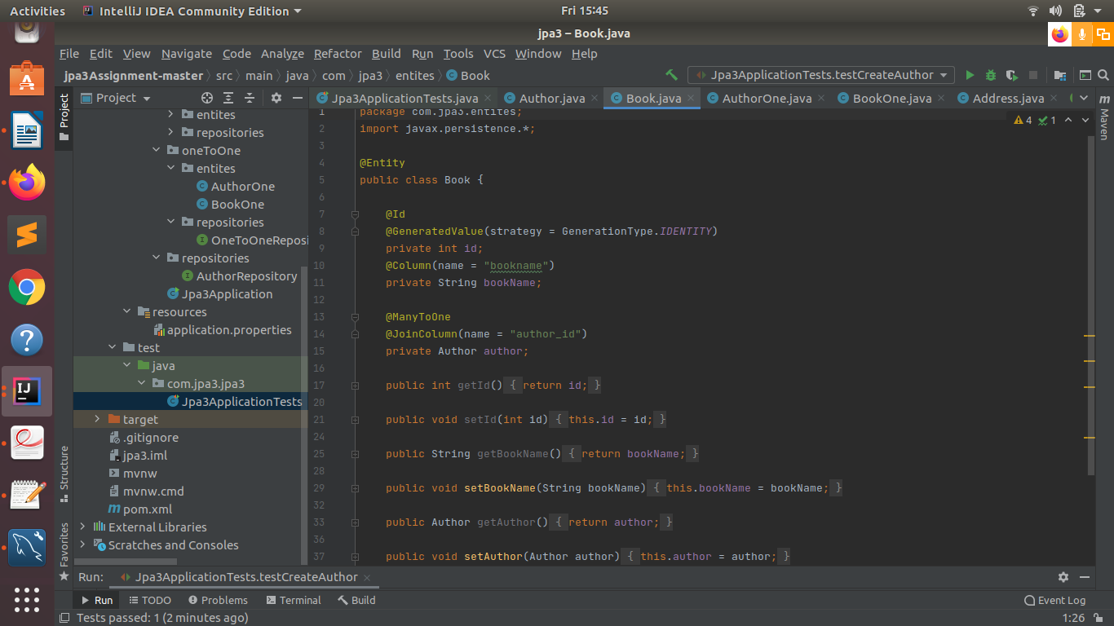

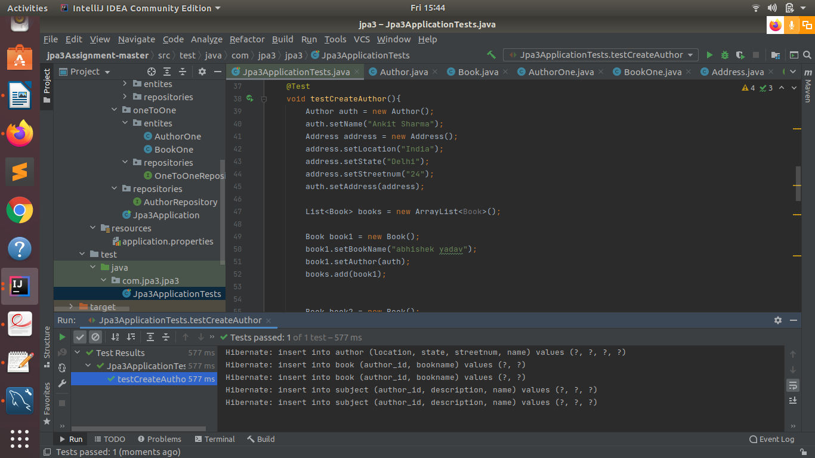

Q8.Implement Many to Many Mapping between Author and Book.
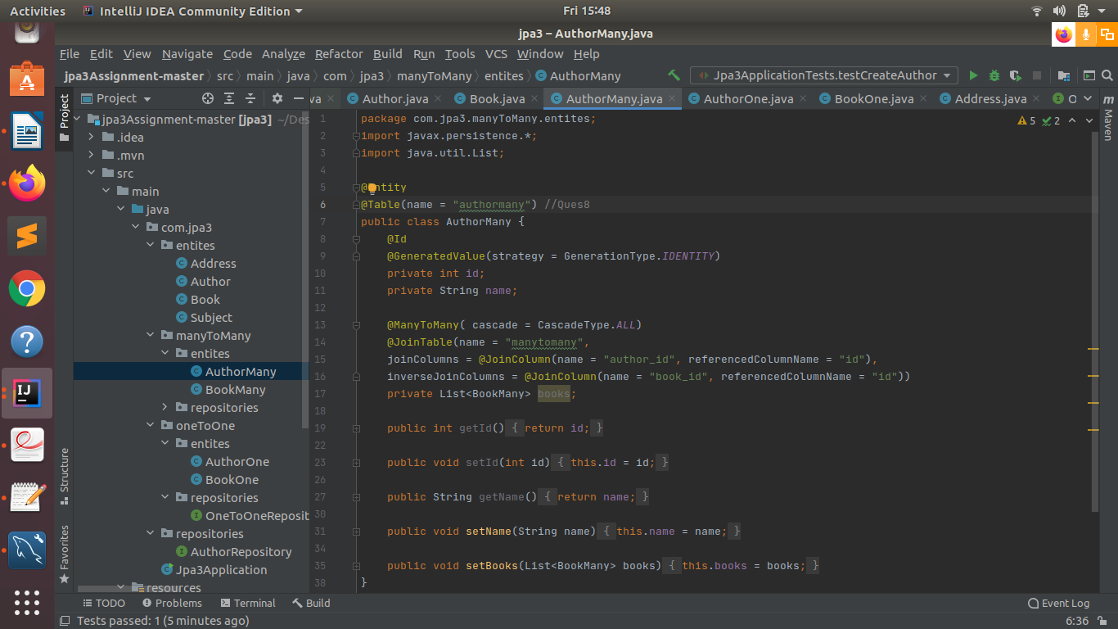
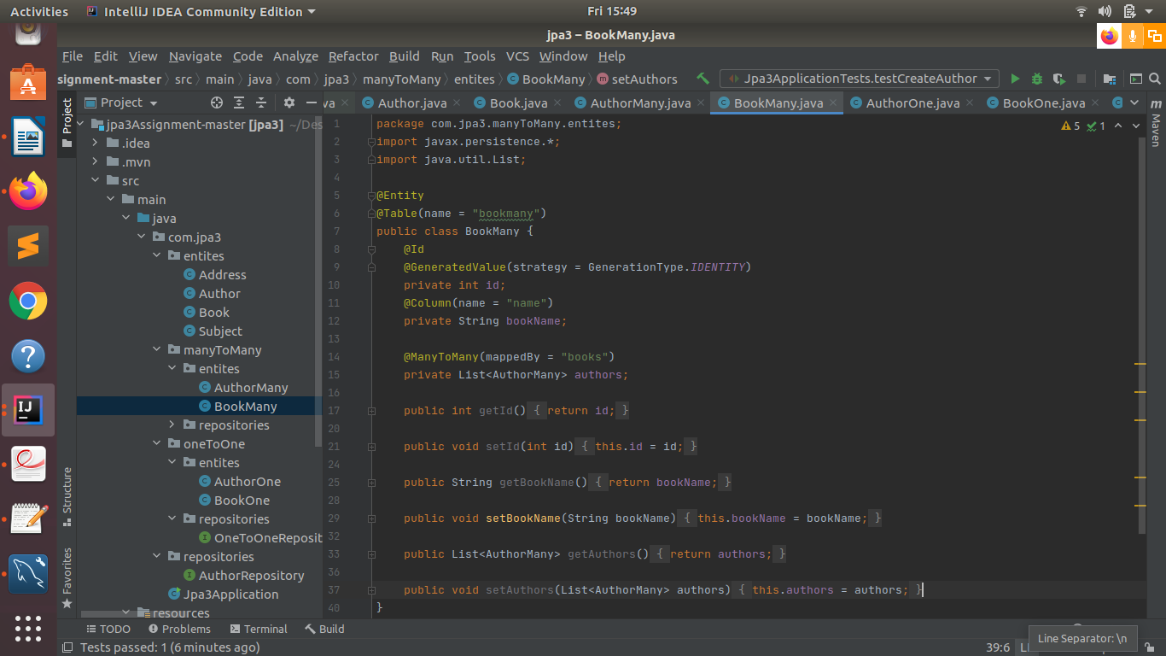

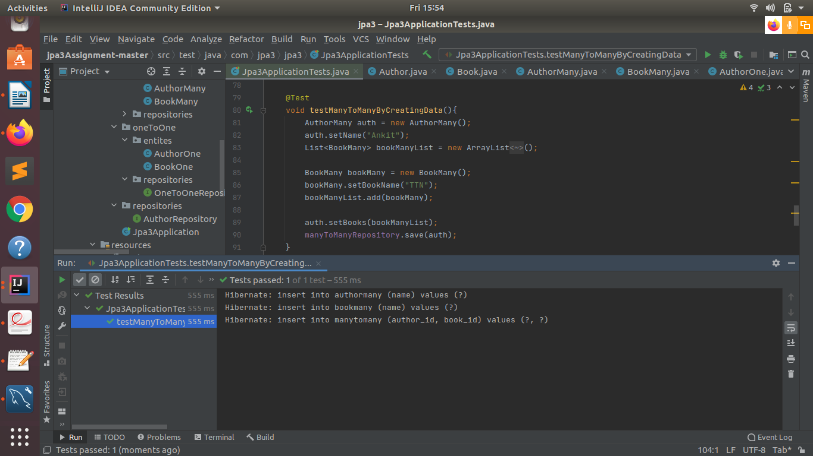

Q9.Which method on the session object can be used to remove an object from the cache?

Ans: => evict() method can be used on the session object to remove an object from the cache.

Q10.What does @transactional annotation do?
Ans:The @Transactional annotation is metadata that specifies that an interface, class, or method must have transactional semantics; for example, "start a brand new read-only transaction when this method is invoked, suspending any existing transaction".

Eg:
@Transectional
//whole transection won’t commit due to t r a n s a c t i o n a l
public v o i d t e s t T r a n s f e r(int amount){
Account account1 = new Account(); Account account2 = new Account();
account1.setBalance(account1.getBalance() - amount); if(true){
throw new RuntimeException();
}
account2.setBalance(account2.getBalance() + amount);
}

